**Recruitnest**

**A hiring and recruitment platform**

**DBS(CS F212) Project**

**BITS PILANI**



Team members:

* Vedant Sindhwani(2022A7PS0055P)
* Armaan Gupta(2022A7PS0145P)
* Namah Gupta(2022A7PS0126P)
* Vibhor Barguje(2022A7PS0137P)
* Tarun Rao(2022A7PS1174P)
* **PROBLEM DESCRIPTION:**

In the current world scenario where job recruitment and hiring is constantly evolving, there are many people who lose the opportunity of making into a better job just because of ignorance about the same. At the same time, many companies fail to choose the right candidates due to the lack of reach. There arises a need to unite them for mutual benefits.

This is where our platform steps in. Whether you're a job seeker looking for that perfect opportunity or a company seeking top talent, our platform offers its multifunctional features to make the journey smoother. Our platform aims to provide the companies with the data of the candidates who are most suited for that job and at the same time provide the trends of the company and the industry so that a job seeker can find the perfect job. Our platform is a one stop solution which can equip you with the knowledge you need to know in today's ever-changing job landscape.

* **FEATURES:**

1. **Account management:** Users can easily create, update and manage their accounts. Job seekers and companies can register, create, update, and delete their profiles as needed.
2. **Candidate search with filters:** Companies can efficiently search for candidates based on desired skills and qualifications. The search results are sorted by relevance, streamlining the hiring process.
3. **Job Search with Filters**: Job seekers can search for positions based on desired fields and attributes, with results listed according to relevance.
4. **Profile Analysis and Job Suggestions**: Candidates receive personalized job suggestions based on their profile's skills and qualifications, enhancing their job search experience.
5. **Position Analysis and Candidate Suggestions**: Companies receive suggestions for candidates ranked by relevance from the pool of applicants for an opening position, facilitating efficient hiring decisions.
6. **Feedback and Rating System**: Users can rate job positions and companies, and provide public reviews to share their experiences, serving as valuable references for other job seekers.
7. **Industry Trends Analysis**: Our platform provides insights into industry trends, including hiring growth, salary growth, in-demand roles, and roles with significant salary growth, aiding users in making informed career decisions.
8. **Company Trends Analysis**: Users can access trends in job postings of individual companies, including sought-after roles, salary growth trends, and diversity hiring ratios, empowering them with valuable insights into potential employers.
9. **Skill Enhancement Recommendations**: Based on candidate profiles and past hiring data, our platform suggests additional or correlated skills that job seekers can learn to maximize their wage growth potential.
10. **Salary Benchmarking**: Our platform offers a feature to compare salaries with similar skilled and experienced individuals, helping users understand their earning potential in the job market.

* **ER MODEL:**

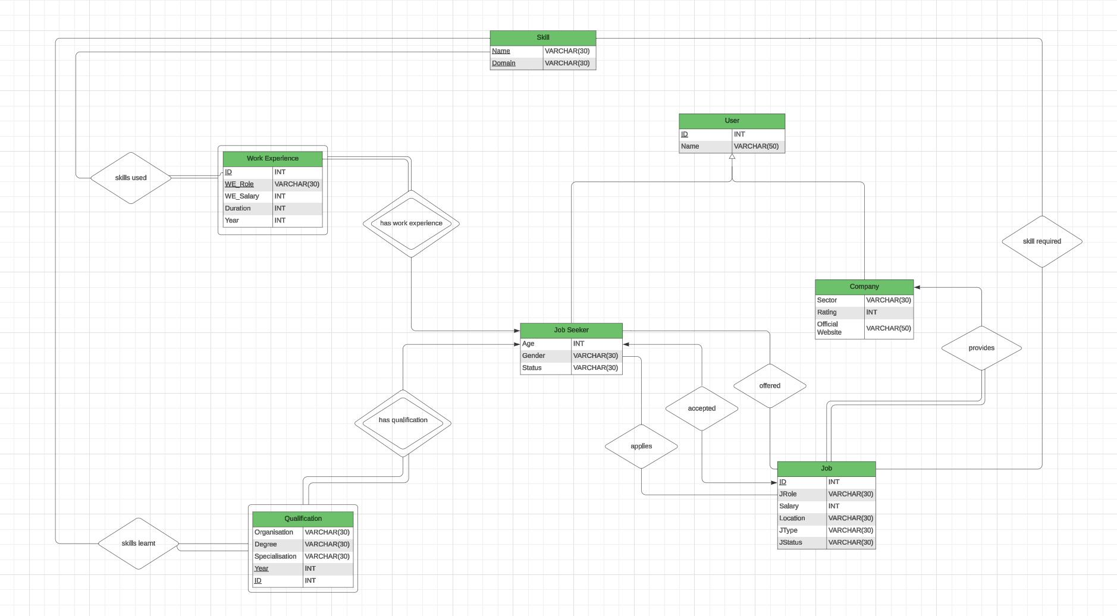

* **RELATIONAL MODEL**
* Company(Com_ID, Com_Name, Sector, Com_Rating, Official_Website)
* Job(Job_ID, Com_ID, JRole, Salary, Location, JType, JStatus)
* Job_Seeker(JS_ID, Name, Age, Gender, JStatus)
* Work_Experience(JS_ID, Com_ID, WE_Role, WE_Salary, Duration,Year)
* Qualification(JS_ID, Organization, Degree, Specialization, Year)
* Applies(JS_ID, Job_ID)
* Accepted(JS_ID, Job_ID)
* Offered(JS_ID, Job_ID)
* Skills_used(JS_ID, Com_ID, WE_Role, Proficiency, Domain)
* Skills_learnt(JS_ID, Year, Proficiency, Domain)
* Skills_Required(Job_ID, Proficiency, Domain)

**Explanation of entities:**

**User** is a **higher level** entity set. **Company** and **Job_Seeker** are its **specializations**. The generalization from Company and Job_Seeker to User is disjoint and complete i.e. **total** thus we will **not create a separate schema** for the User.

* **Company (Com_ID, Com_Name, Sector, Com_Rating, Official_Website):**
  + **Com_ID**: Unique identifier for each company**. (P_key)**
  + Com_Name: The name of the company.
  + Sector: The industry or sector in which the company operates.
  + Com_Rating: Rating or evaluation of the company, based on performance or reputation.
  + Official_Website: The official website of the company.
* **Job_Seeker (JS_ID, Name, Age, Gender, Status):**
  + **JS_ID**: Unique identifier for each job seeker. **(P_key)**
  + Name: Name of the job seeker.
  + Age: Age of the job seeker.
  + Gender: Gender of the job seeker.
  + Status: Current status of the job seeker (e.g., actively seeking, employed).
* **Job (Job_ID, JRole, Salary, Location, JType, JStatus):**
  + **Job_ID**: Unique identifier for each job position. **(P_key)**
  + JRole: The role or position available within the company.
  + Salary: The salary associated with the job.
  + Location: The location where the job is based.
  + JType: Type of employment (e.g., full-time, part-time, contract).
  + JStatus: Current status of the job (e.g., open, closed).
* **Work_Experience (Com_ID, WE_Role, WE_Salary, Duration):**
  + **Com_ID**: **Foreign key** **referencing** the **Company** entity. **(partial_k)**
  + **WE_Role**: Role or position held during work experience. **(partial_k)**
  + **WE_Salary**: Salary associated with the work experience. **(partial_k)**
  + **Duration**: The duration of the work experience. **(partial_k)**

All the four above mentioned attributes together act as **partial key/discriminator**. Along with **JS_ID** from the Job Seeker table, they all act as **primary keys.**

* **Qualification (Organization, Degree, Specialization, Year):**
  + **Organization**: The educational or training organization. **(partial_k)**
  + **Degree**: The degree obtained by the job seeker. **(partial_k)**
  + **Specialization**: Specialization or major of the degree. **(partial_k)**
  + **Year**: The year in which the qualification was obtained. **(partial_k)**

All the four above mentioned attributes together act as **partial key/discriminator**. Along with **JS_ID** from the Job Seeker table, they all act as **primary keys.**

* **Explanation of relationship sets:**
* **Provides (Com_ID, Job_ID):**
  + Relationship entity indicating which companies provide which job positions.

**Com_ID** along with **Job_ID** act as the **primary key**.

**Foreign key** **Com_ID** references **Company** entity set

**Foreign key** **Job_ID** references **Job** entity set

Cardinality constraint: This is **one to many** relationship with each company providing multiple job listings but each job listing only having one company that it is listed by.

Participation constraint: This is a **total relationship** from the side of **Job** as each job listing will have a company associated with it. It is a **partial relationship** from the side of the Company as each company might not have a job listing on the platform.

* **Applies (JS_ID, Job_ID):**
  + Relationship entity indicating which job seekers have applied for which job positions.

**Com_ID** along with **JS_ID** act as the primary **key**.

**Foreign key** **JS_ID** references **Job_Seeker** entity set

**Foreign key** **Job_ID** references **Job** entity set

Cardinality constraint: This is a **many to many** relationship with each job seeker applying to multiple jobs and each job listing having applications from multiple job seekers.

Participation constraint: This is a **partial relationship** from the side of **Job** as every job listing might not have a job seeker applying to it. It is a **partial relationship** from the side of **Job Seeker** as a job seeker might not apply to any job listing on the platform.

* **Accepted (JS_ID, Job_ID):**
  + Relationship entity indicating which job seekers have been accepted for which job positions.

**Com_ID** along with **JS_ID** act as the **primary key**.

**Foreign key** **JS_ID** references **Job_Seeker** entity set

**Foreign key** **Job_ID** references **Job** entity set

Cardinality constraint: This is **one to one** relationship with each job seeker accepting only a single job listing and each job listing with a specific Job_ID accepting only a single job_seeker.

Participation constraint: This is a **partial relationship** from the side of **Job** as every job listing might not have a job seeker accepting the job. It is a **partial relationship** from the side of **Job Seeker** as a job seeker might not accept any job listing on the platform.

* **Offered (JS_ID, Job_ID):**
  + Relationship entity indicating which job seekers have been offered which job positions.

**Com_ID** along with **JS_ID** act as the **primary key**.

**Foreign Ke**y **JS_ID** references **Job_Seeker** entity set

**Foreign key** **Job_ID** references **Job** entity set

Cardinality constraint: This is a **many to many** relationship with each job seeker being offered multiple jobs and each job listing offering the job listing to multiple job seekers.

Participation constraint: This is a **partial relationship** from the side of **Job** as every job listing might not offer a job to any job seeker through the platform. It is a **partial relationship** from the side of **Job Seeker** as a job seeker might not be offered any job listing on the platform.

* **Skills_Used (JS_ID, Com_ID, WE_Role, WE_Salary, Duration, Proficiency,Domain):**
  + Com_ID: **Foreign key** **referencing** the **Company** entity.
  + JS_ID: **Foreign key referencing** the **Job_Seeke**r entity.
  + WE_Role: Role or position where the skills were used during work experience.
  + WE_Salary: Salary associated with the work experience where the skills were used.
  + Duration: The duration of the work experience where the skills were utilized.
  + Proficiency: The skill used during the work experience.
  + Domain: The domain or category to which the skills belong.

Cardinality constraint: This is a **many to many** relationship with each skill being used in multiple work experiences and each work experience requiring use of multiple skills.

Participation constraint: This is a **partial relationship** from the side of **Skill** as every skill known by the candidate might not have been used in any job previously. It is a **total relationship** from the side of **Work Experience** as each work experience will have certain skills used by the candidate there.

* **Skills_Learnt (JS_ID, Organization, Degree, Specialization, Proficiency, Domain):**
  + JS_ID: **Foreign key referencing** the **Job_Seeke**r entity.
  + Organization: The educational or training organization where the skills were learned.
  + Degree: The degree obtained by the job seeker.
  + Specialization: Specialization or major of the degree where the skills were learned.
  + Proficiency: The skill which was learnt in the organization
  + Domain: The domain or category to which the skills belong.

Cardinality constraint: This is a **many to many** relationship wherein each skill might have been learned in multiple qualifications and in each qualification a job seeker might have learnt multiple skills.

Participation constraint: This is a **partial relationship** from the side of **Skill** as every skill known by the candidate might not have been learnt through a specific mentioned qualification. It is a **total relationship** from the side of **Qualification** as each qualification will have certain skills learnt by the candidate there.

* **Skills_Required (Job_ID, Proficiency, Domain, Years of experience):**
  + Job_ID: **Foreign key referencing** the **Job** entity.
  + Proficiency: The skill associated with a particular job seeker
  + Domain: The domain or category to which the skills belong.
  + Years of experience: The number of years of experience required for the specified skills in the job position.

Job_ID along with proficiency and domain act as **primary key.**

Cardinality constraint: This is a **many to many** relationship with each job listing requiring multiple skills and each skill being required in multiple job listings.

Participation constraint: This is a **total relationship** from the side of **Job** as every job listing will require some skills. It is a **partial relationship** from the side of **Skills** as there might be a skill that was not mentioned as required in any job listing.

* **Technical Details:**
* The tables present in the schema are

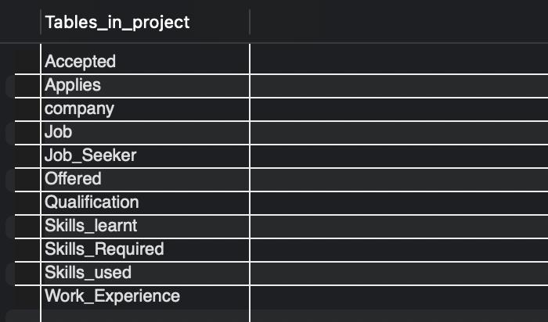

* Creating all the tables required in the database

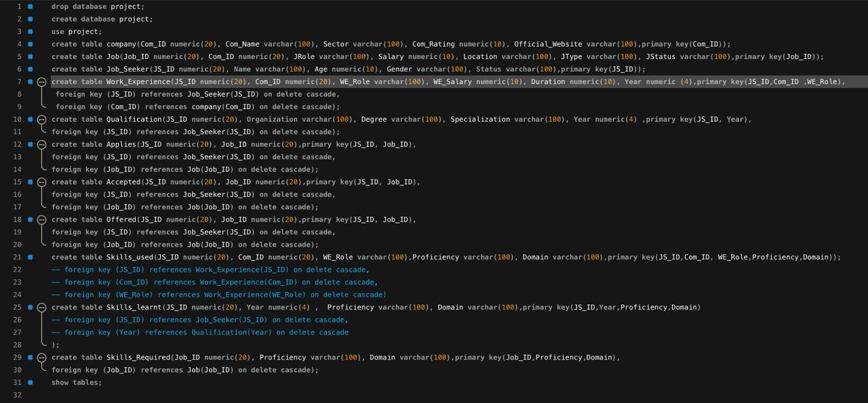

* Inserting values into the database

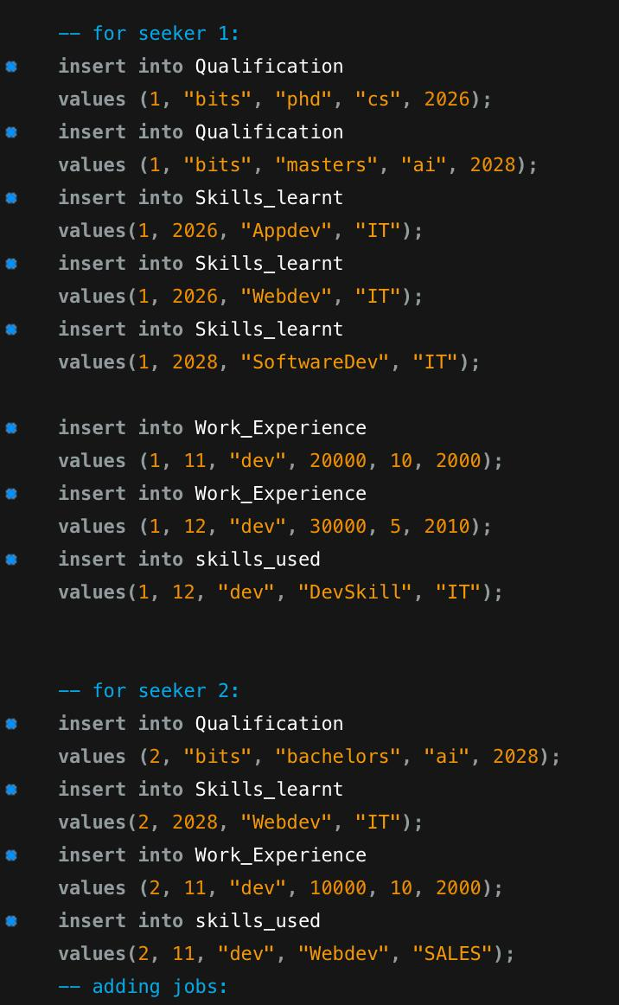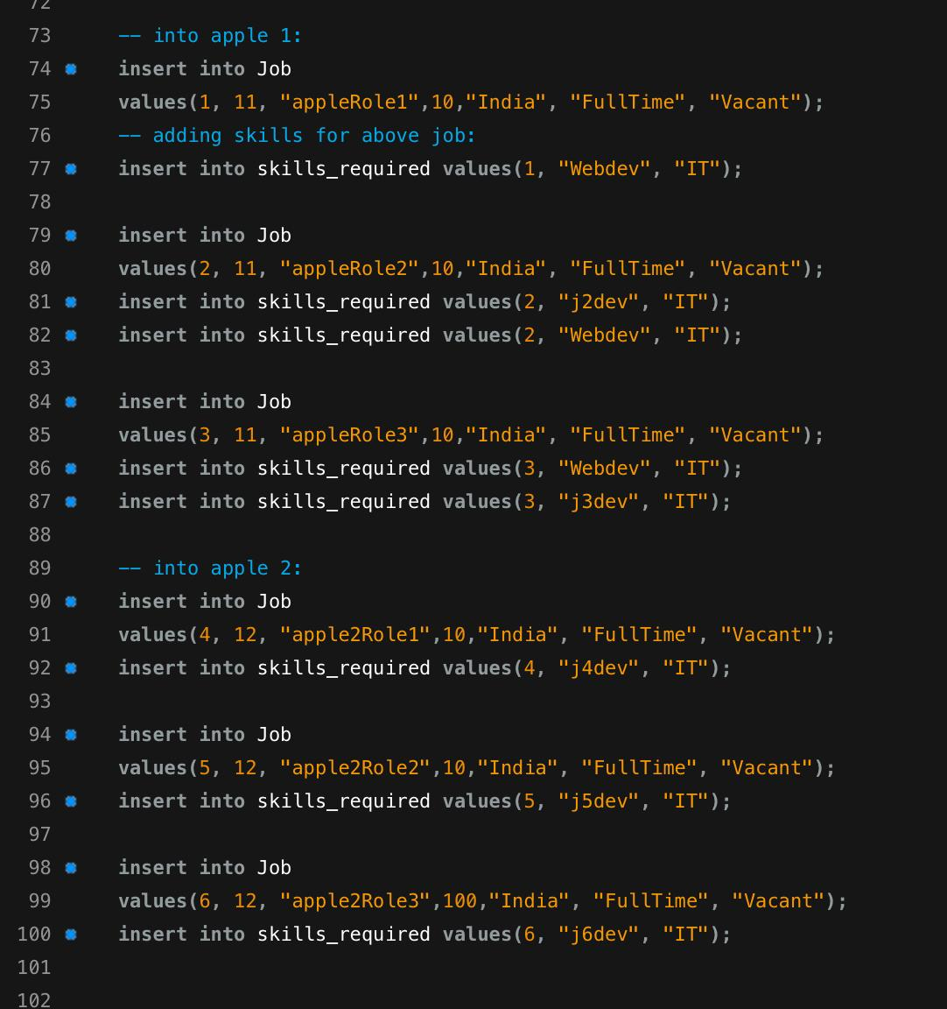

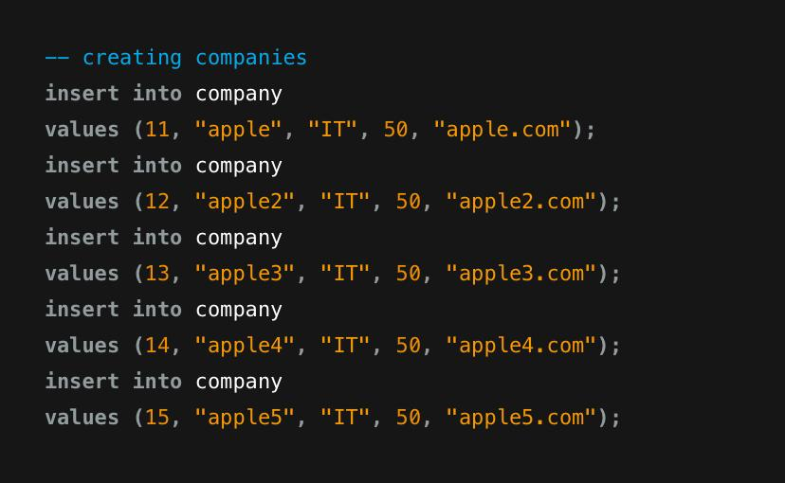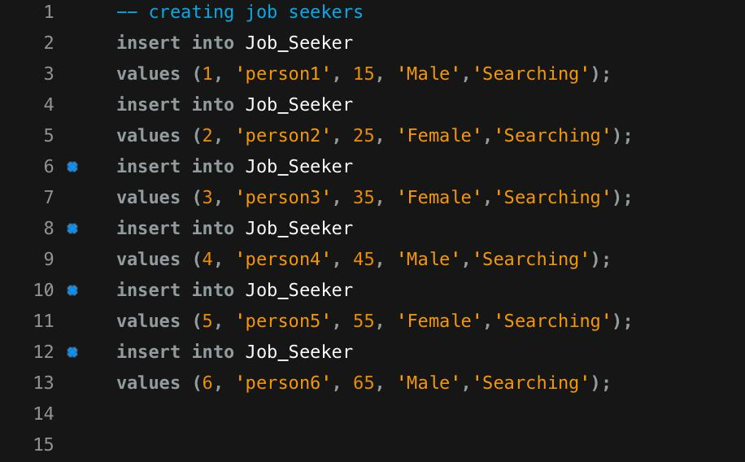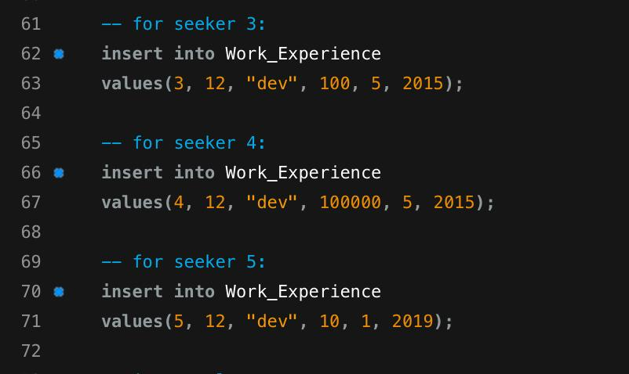

* Tables corresponding to the inserted data

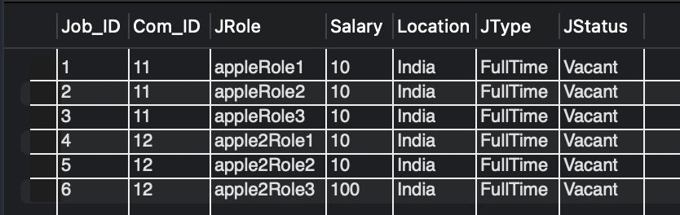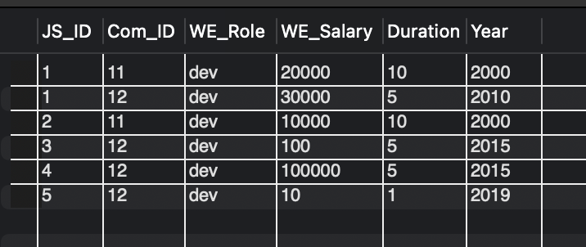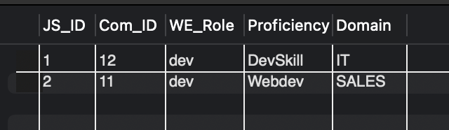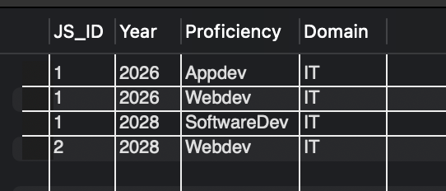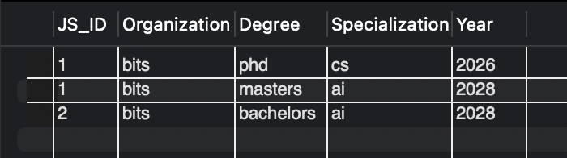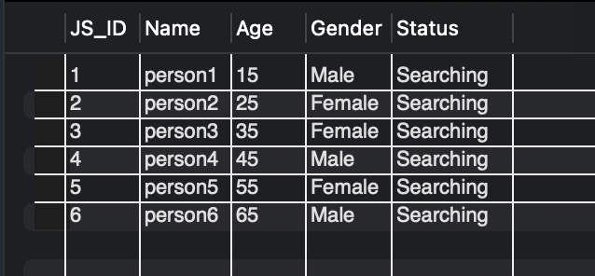

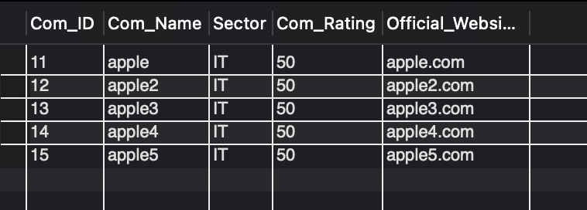

* Complex queries with output

Query 1:

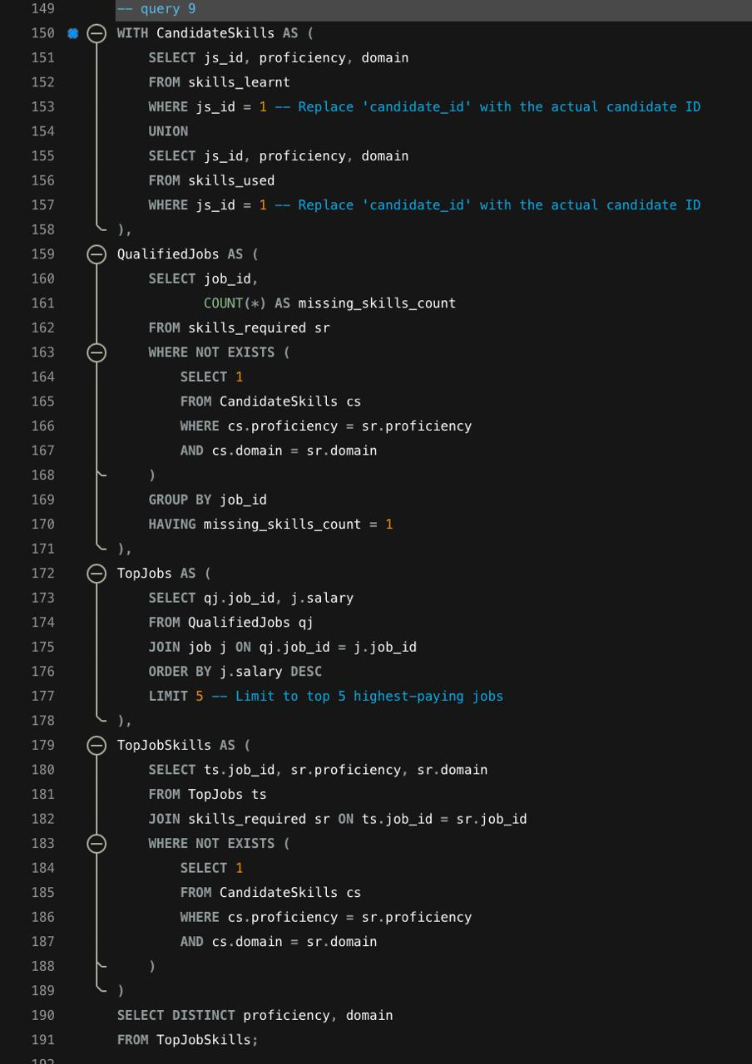

Output:

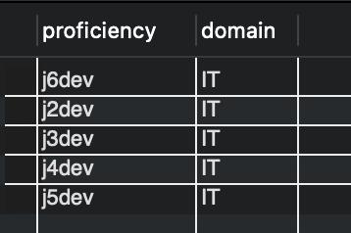

Query 2:

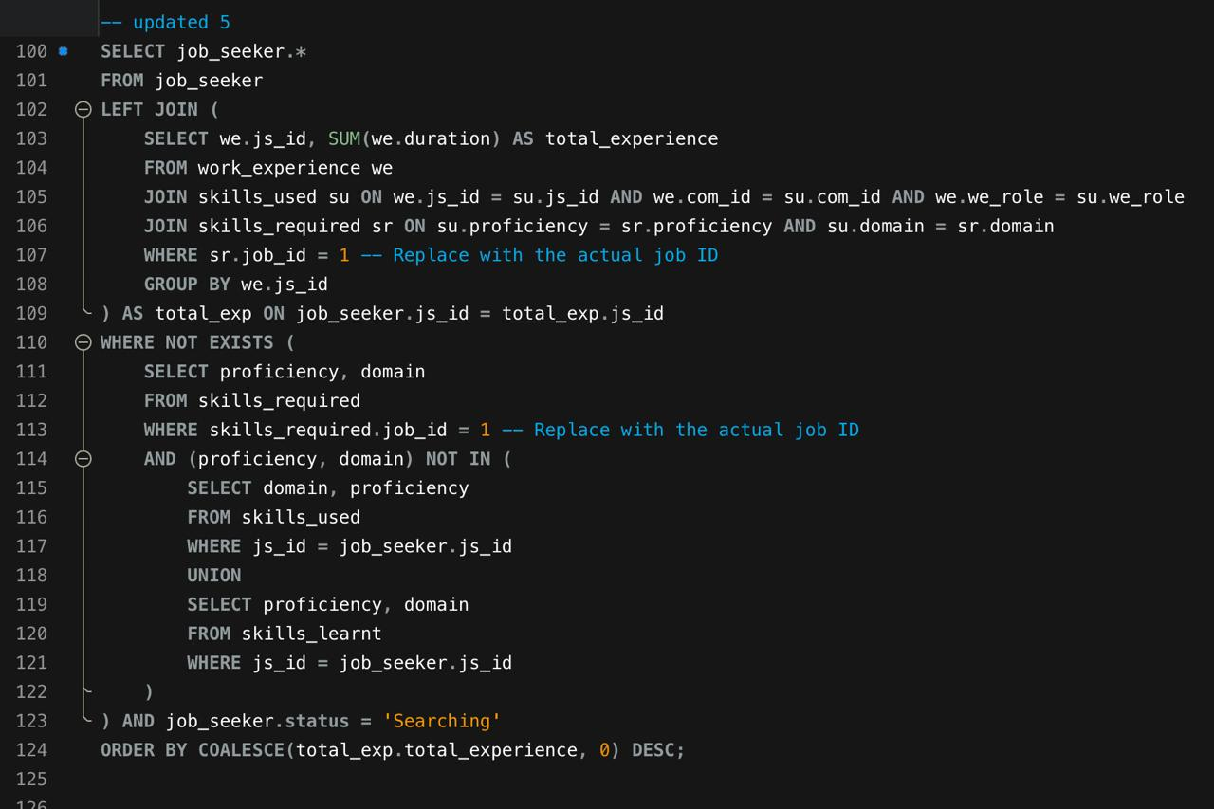

Output:

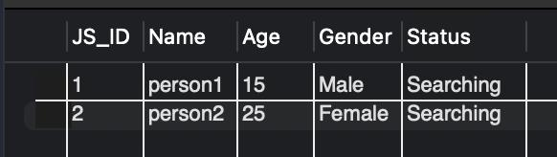

Query 3:

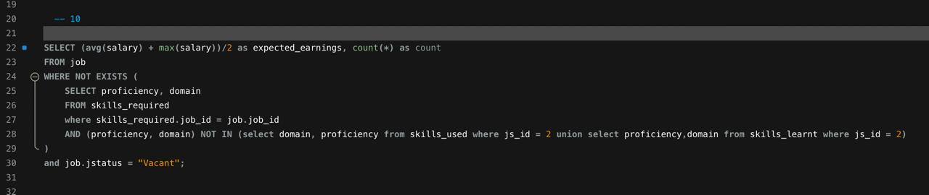

Output:

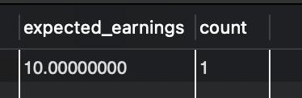

* **Conclusions:**

In summary, our hiring and recruitment platform is designed to make finding jobs and hiring people easier for everyone involved. With features like easy account management, personalized job suggestions, and insights into job market trends, our platform helps job seekers and companies make better decisions.

By offering tools to search for jobs or candidates, providing feedback on experiences, and keeping up with industry trends, our platform aims to be helpful and easy to use. We're committed to keeping our platform updated and useful as the job market changes, so that everyone can find the right fit for their needs.